A Machine Theory of Mind for Processing 5-way Social Networks

Yen-Ling Lai¹, Jessica Le², Chih-Yi Chen¹, Yun-Shiuan Chuang³, Li-Chen Fu^{4,5}, Joshua Oon Soo Goh^{1,5,6,7}

1. Graduate Institute of Brain and Mind Science, National Taiwan University, Taiwan.
2. Cognitive Science Department, Yale University, CN, USA.
3. Psychology Department, University of Wisconsin-Madison, WI, USA.
4. Department of Electrical Engineering, National Taiwan University.
5. Center for Artificial Intelligence and Advanced Robotics, National Taiwan University.
6. Department of Psychology, National Taiwan University.
7. Neurobiological and Cognitive Science Center, National Taiwan University.

Running Title: Social Networks in Machine Theory of Mind

Correspondence:
Joshua Oon Soo Goh, PhD
No. 1 Sect. 1 Ren-Ai Rd. RM 1245
Zhongzheng District, Taipei
Taiwan 10051
joshuagoh@ntu.edu.tw
+886-2-2312-3456 ext. 288022
Abstract
Social networks define the structure of human inter-relationships. Critically, such structures are abstract and hidden such that learning about them requires the ability to infer hidden states from observations of social preference behaviors. Human beings do this very naturally in using inferred social knowledge for smooth daily communication and interaction with each other. A key challenge in human robot interaction (HRI) is to imbue machines with similar ability to engage with humans naturally. In this study, we consider that in order to design machines that interact effectively with humans, the artificial intelligence driving these machines should also be able to infer social networks from observations of human social behaviors. Our previous iteration of a Machine Theory of Mind (ToMNet+; modified based on principles applied in Google DeepMind projects) displayed the ability to observe social interaction behaviors and infer simple human social networks, but its performance against complex social structures remains unclear. In this present study, we expanded ToMNet’s structure and built ToMNet 2.0. ToMNet 2.0 has the capability to infer more complex human social networks consisting of five dynamically interacting agents each with its own set of social preferences for the other four agents in the social network. We demonstrate that ToMNet 2.0 is able to abstract the hidden social preferences of the five agents from untrained social networks by utilizing additional social preference information compared with ToMNet. This raises the potential for ToMNet 2.0 to be applied in socially assistive robots problems more broadly.
Keywords: artificial neural networks, social networks, Theory of Mind, multi agent.
1. Introduction
1.1 Toward Theory of Mind in Machines
Theory of Mind (ToM) is the ability of an agent to internally instantiate a model of another agent’s beliefs or intentions (or mental models), and is a key cognitive ability of at least higher order living organisms such as humans. Several human Theory of Mind (ToM) aspects are believed to be developed by the age of 5 years, such that ToM in childhood is a critical component to allow children to attribute mental states to others that aids the child’s social skills, important for normative developmental societal integration and interaction [12, 13]. Similarly, developing machines that have the capacity for ToM has become increasingly important and essential when interactions are growing more elaborate between machines and humans [11]. However, [14] reflects that there is a the lack of trust in humans for machines, which might be caused by current models focusing on reproducing exhibited behavior (i.e., input-output mapping) rather than being driven by an internal model of others’ mental states (i.e., ToM). Thus, imbuing machines with ToM stands as a critical barrier to enhancing social connections between humans and machines or robots.
Models based on multiagent deep reinforcement learning (MDRL) architectures are potential candidate algorithms to feasibly embed ToM in machines. A survey of recent multiagent learning (MAL) [15] points out Machine Theory of Mind [16] could be classified as a series of multiagent deep reinforcement learning (MDRL) models that have the ability to perform agent-modeling-agents functions. These models are inspired from either deep reinforcement learning (DRL) or MAL structures. Examples of early related work include the Deep Reinforcement Opponent Network (DRON) and Deep Policy Inference Q-Network (DPIQN), which are models that learn their action policies through observing opponents or teammates. Other algorithms in this category include the Self Other Modeling (SOM) approach that estimates the opponents goals in the agent’s self policy, the Neural Fictitious Self-Play (NFSP) and Deep Cognitive Hierarchies (DCHs) that combine game theory and Multiagent learning (MAL), the Minimax Multiagent Deep Deterministic Policy Gradients (M3DDPG) approach that applies the concept of minimax in game theory and MAL, the Learning with Opponent-Learning Awareness (LOLA) approach that anticipates the updated policies of other agents to maximize reward, and the Deep BPR+ approach inspired by BPR+, which is a Bayesian policy reuse framework with policy distillation. The above mentioned MDRL models do somewhat involve agent-modeling-agents functions, however there are still gaps in these approaches to ToM ability in machines.
To this end, Deep Bayesian Theory of Mind Policy (Bayes-ToMoP) applied theory of mind concepts in agent-modeling-agents tasks. Bayes-ToMoP has a similar setting to BPR+ and is said to have the ability to process high-level reasoning strategies and also better self-playing performance. However, Bayes-ToMoP is trained based on the reward of the opponent, constructed as a value based DQN model design [15], which may limit the implementation of social scenario applications.
It has been suggested in [15] that models focusing on recursive reasoning approaches may be a key factor in effective models with machine Theory of Mind to represent the mental states in others. However, the use of recursive learning usually requires numerous training data. Critically, machine Theory of Mind models have been ascribed as meta-learning models [16]. Indeed, meta-learning is also regarded as a critical feature of mature machine ToMs [11]. Taken together, meta-learning algorithms which are designed to learn from a limited amount of training data, may be candidate models to continuously learn and update concepts in contexts of being embedded in human social interactions.

1.2 ToMNet+
The original ToMNet model as described by the Google DeepMind team was applied in grid world simulations. The model can be divided into two parts, the learning (character net) and predicting (prediction net) parts. The character net picks up agents’ movement interaction behaviors provided by grid world simulations as inputs. Subsequently, the prediction net predicts the outcome of agent positions or movements given the information acquired by character net and the initial positions of novel grid world start positions of agents. This algorithm structure is quite reasonable if we regard the prediction net as reducing entropy by learning some sort of information about the agents embedded in the learned simulations.
ToMNet has achieved comparable human level performance when tested on its capacity to engage theory of mind functions, such as in tests involving partial observability and the classical Sally-Anne test of false belief mental models in others [16]. These test performances reveal ToMNet’s difference in comparison to the previously mentioned algorithms, and highlights the possibility for implementing ToMNet in social machines. Several different variations of ToMNet applications have emerged due to it’s potential in enhancing machine social skills. These include testing ToM models on Few-shot Language Coordination [17], testing ToMNet’s performance in comparison to infants [18]. However, ToMNet has not yet been trained or tested in simulations with embedding of data on social interaction behaviors between agents driven by the agents’ preferences [16]. Thus, there remains a knowledge gap for demonstrating if ToMNet function can be used to a certain degree to represent the internal underlying mental states of others or some hidden information structures purely through observed behavioral interaction inputs.
To bridge this gap, in ToMNet+ [19], we applied a modification of ToMNet [16] onto social scenarios designed to evaluate the ability of such algorithms to identify embedded social preference information structures. Our ToMNet+ study utilized two different sets of training data, including the simulation data and real human generated data. Each data set had the same format of input grid worlds with an agent approaching one of four targets, which were scattered in various locations in each grid world instance. Distance traveled was applied as a penalty such that ToMNet+ essentially learns associative functions that weigh the cost of approaching different targets in grid world against the social utility of approaching each target. Critically, the targets are construed as the central agent’s relatives with different social preference weightings (i.e. the central agent has a social preference score with respect to each target agent). In the simulated grid worlds, the agent was triggered to move by calculating the difference between social scores and the path distance (i.e., the minimal number of steps to target agents). We showed that ToMNet+ was able to recognize social preferences embedded in the grid world movement behaviors both in simulations and human generated data sets. However, one severe limitation was that the grid world stimuli restricted ToMNet+ to gaining only unidirectional social information. That is, ToMNet+ was only trained on scenarios where one central agent had social preferences for four other target agents. Thus, it is still not clear whether ToMNet+ can be adapted to learn bi-directional social preferences between the five agents involved in the grid world simulations. This is important as it reflects more ecologically valid situations in daily human social life.
The results in ToMNet+ stands as proof-of-concept for implementing simple social interaction structures in relatively similar simulations as in ToMNet [16]. From here, therefore, we can expand a range of evaluations and broad applications. In this present research, we expanded the stimuli settings to test the performance of ToMNet 2.0 to distinguish more complex social structures that are closer to real life.

1.3 ToMNet 2.0
In this present study, our purpose is to evaluate if a modification of ToMNet+, ToMNet 2.0, is able to similarly predict social behavioral outcomes from observed social interactions constructed based on more complex, dynamic, and ecologically valid social structures. Based on this reasoning, we first set our embedded social structures such that all agents in the social network maintained bidirectional social preferences. i.e., each agent has different preferences for the other four agents. In addition, we defined the interactive movements of these agents in grid world simulations as five-bodied problems where the five agents move dynamically akin to bodies orbiting each other due to their gravitational forces acting on each other differently at different time steps. i.e., from the start states, the agents move based on the resultant weightings of the influences of the distances between them and their social preferences for each other. Subsequently, the agent positions are updated and the distances between them have changed, driving a new resultant weighting that effects the next set of movements, and so on. We decided to use a five agent case because this is the minimal group size in which it is possible to have variable sizes of social clustering of agents (1 vs. 4, 2 vs. 3, 2 vs. 2 vs. 1, etc.), which increase the richness of the training data. Moreover, we extended the simulation grid size to provide different information inputs (see Methods). Overall, the key goal in this study is to evaluate if ToMNet 2.0 has the ability to observe the grid world social interaction behaviors of five agents, which are driven by bidirectional social preferences applied in a dynamic manner, and subsequently predict how the agents will behave in novel grid world situations.

1.4 Hypothesis
Formally, we hypothesize that ToMNet 2.0, which is augmented from ToMNet+ in terms of the ability to accept increased dimensions of input information, after being trained on variable observations of how five agents interact in grid world, will be able to produce predicted outcomes of how five agents will interact in novel untrained grid world scenarios. The requisite for this ability is that the grid world interactions of the five agents stem from a real underlying driving social network structure which is hidden with respect to ToMNet 2.0. In this manner, ToMNet 2.0 can be said to maintain an internal representation model of external hidden information structures — having a form of Theory of Mind. If successful, ToMNet 2.0 might bring us one step closer towards a more effective socially assistive machine.

1.5 Significance & Motivation for Improving Social Machines
Improving Human Robot Interactions (HRI) for the purposes of utilizing machines as social companions, such as social robots, in human daily life is of great interest across many technological research areas and applications [1]. A general consensus is that a social machine should have the ability to communicate messages or engage cooperative actions with other agents while demonstrating autonomy and flexibility in its choices of messages or actions [2]. In general, social machines are primarily trained to engage outputs that are mapped (albeit using various sophisticated methods) to input feature-level indices derived from data on eye gaze, facial expressions, gestures, movements, and speech. Humans are more accepting of robots that express emotions in a dynamic rather than static manner [6], suggesting that social machines with richer emotion input and output mappings are better at achieving social goals. Moreover, robots that exhibit more complex emotional repertoires via mimicry of participants’ expressions and gestures engaged more successful interactions with patients [7]. While studies show that social robots can already improve mental status for participants experiencing loneliness, depression, or stress [9, 10], there are still various barriers to the use of social robots in normative life [10]. Most notably, social robots are unable to be autonomously deployed because they lack the ability to interpret more complex and dynamic interactive behaviors that are not present in the limited training environment.
Critically, in this present study, we consider then that to be socially assistive machines, the machine cannot merely map input emotion features to output actions. They cannot merely be powerful emotion processors or life-like action actuators, they need to have an internal representation model of the external information structure that drives human social behaviors to match the true complexity of human social experience. To this end, we suggest that the social machine requires Theory of Mind to be truly socially assistive [11]. This forms the conceptual motivation driving this present study.

2. Methodology

2.1 The social game for simulated agents
In our simulation approach for agent-to-agent interactions, social actions are driven by embedded social structures. This principle was applied in our previous work on ToMNet+ [19], which was modified from Google DeepMind’s ToMNet model [16]. In that study, a given agent, s, had different social utility scores for other four goal agents, a₁, a₂, a₃, a₄ (Fig. 1A). These agents were then placed in various locations in a gridworld and then the agent, s, moved towards one of the goal agents based on the social utility score and path distances. The agent movement loss functions are detailed below. This setting, however, instantiates a mono-directional social structure representation of one subject agent’s preferences toward four goal agents.
In this present study, we implemented dynamic 5-agent interaction simulations and applied ToMNet 2.0, which is modified from ToMNet+ to evaluate the models ability to represent more complex and ecologically valid social interactions. Social scores were applied to 5 agents (a₁, a₂, a₃, a₄, a₅), with each agent having a randomized social score for the other four agents (Fig. 1B & C). The social score range was set at [40, -40] for arbitrary simulation purposes. Other score ranges could be set in subsequent studies. We will focus on our current setting here with some further range inferences described below in section B. Further, the means of total social scores differ for each training set used such that the means were set at 0, 16 and -8 in three different data sets. These different mean social scores between training set mimics social networks in which the net social preference is neutral, attractive, or repulsive, respectively. The given social scores along with the distances between agents in the grid then affects all agents’ movements in a manner described in section B. This social score setting is preserved through each entire simulation data set. Thus, the main difference between social structures used in ToMNet+ and ToMNet 2.0 is that the social preferences fed to ToMNet 2.0 are bidirectional with all five agents having both efferent and afferent social preferences with each other. This can be represented as P_{i,j}^{efferent} and P_{i,j}^{afferent} between each pair of agents

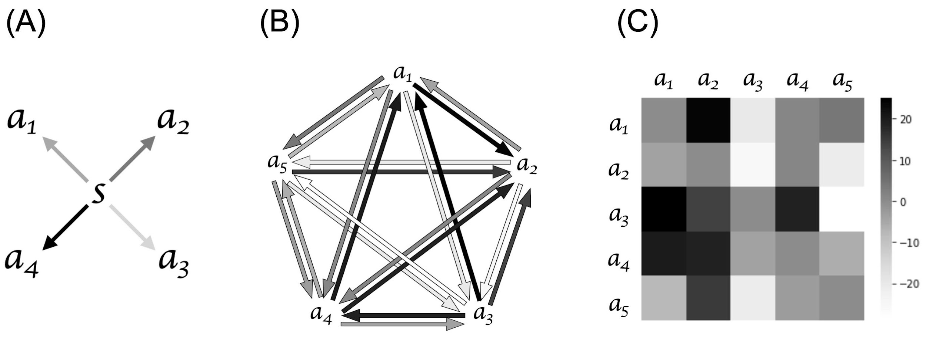
Figure 1 (A) represents the ToMNet+ social structure that projects S has different social preference between a₁, a₂, a₃, and a_{4.} The scale of grey arrow indicates the preference score of S for the other four agents. In Figure 1 (B) the bidirectional arrows refer to agents having different social scores for each other. The scale of the grey arrows represents the social scores that are also shown in Figure 1 (C), with white indicating social scores at -30 and black indicating social scores at 30. This 5-agent social structure has a neutral net social preference (equal balance of attraction and repulsion).

Here we formalize the learning task. The training involves observing a series of interactions with five dynamic agents that produces trajectories within a query state for which ToMNet2.0 must make a set of predictions. The task of the observer is to predict the agents’ preferences, behavior, and latent states on the current episode as it acts within each unique grid world. To model social interactions and predict agent behaviors in grid environments, we assume a partially observable Markov decision process denoted as tuples consisting of trajectories T_{j}, query states q_{k}, and target preferences g_{k}. The model is trained end to end with these tuples M_{j} = (T_{j}, q_{k}, g_{k}), forming the basis of our training dataset. After training, the model should be able to abstract agent’s character embedding e_{char, j} from trajectory T_{j} and ultimately utilize preference information from e_{char, j} along with query states from a novel grid q_{k} to predict which target the agent will approach g_{k}^{* hat}.
The tuple’s reward functions, discount factors, and conditional observation functions are associated with each of the five agents rather than the model itself. Thus, the model operates under a partial observability and from a strict third person view, which only perceives the state observation function and lacks direct access to private hidden states of the agents. The observation space Ω_{i} can be represented by conditional observer accessible identity functions ω_{i}(·) : q → Ω_{i} , with q being the state observation and Ω_{i} the noisy observation.
This structure reflects real world scenarios where third person agents observing social interactions may have limited information about its environment and agent’s intentions, leading to the need for sophisticated learning algorithms capable of making decisions with incomplete information. By leveraging the tuples in our training dataset and accounting for partial observability with the POMDP framework, the model aims to learn dynamic representations of the environment and bidirectional agent behaviors that enable effective prediction and decision making in complex grid environments.

2.2 Projecting social interaction scenario into grid world
Grid world simulations that contained agents' movements were used to represent human social interaction structure, this is an application of allowing topological maps capturing various information relationships, which in this case was social network information[20].
In the grid world simulations, we set up a 24 x 24 grid world with a 12 x 12 focal area in the central. ToMNet model observes the 12 x 12 focal area, while the 24 x 24 grid contributes information and continuous effect of agents dynamic movements that is not observable for ToMNet. In each simulation, four agents were randomly located in the central (12 x 12) area, and moved freely in the grid (24 x 24) later on, with one agent fixed in the center of the grid (Fig. 2A). The fixation on one of the agents was a practical implementation to generally keep most of the agents’ migrations in the 12 x 12 grid field of view rather than constraining the migrating flow of agents within some boundaries. If this were not applied, the centroids of agent locations may migrate out of the focal area while converging. This may lead to some simulation trials possibly having no agents within the 12 x 12 grid only after a few movement iterations. All five of the agents were sequentially fixated on in a counterbalanced manner across all simulation trials.
In each simulation trial, once the agents have been located in the grid world, the social preferences drive the movement of agents (a₁, a₂, a₃, a₄, a₅) in the grid. With the starting state as ₀, _{n} represents the state after n steps of movement. From _{n} to _{n+1} we calculate the movement force (F_{social}) for every agent in the _{n} position. Calculating the movement force (F_{social}) includes the information of distance (r) between each agent at _{n} and the social score (Q_{i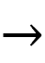j}). The movement force (F_{social}) on _{n} is then calculated based on the formula stated below which, for those interested who notice, is similar to the electrostatic force that follows Coulomb’s law:
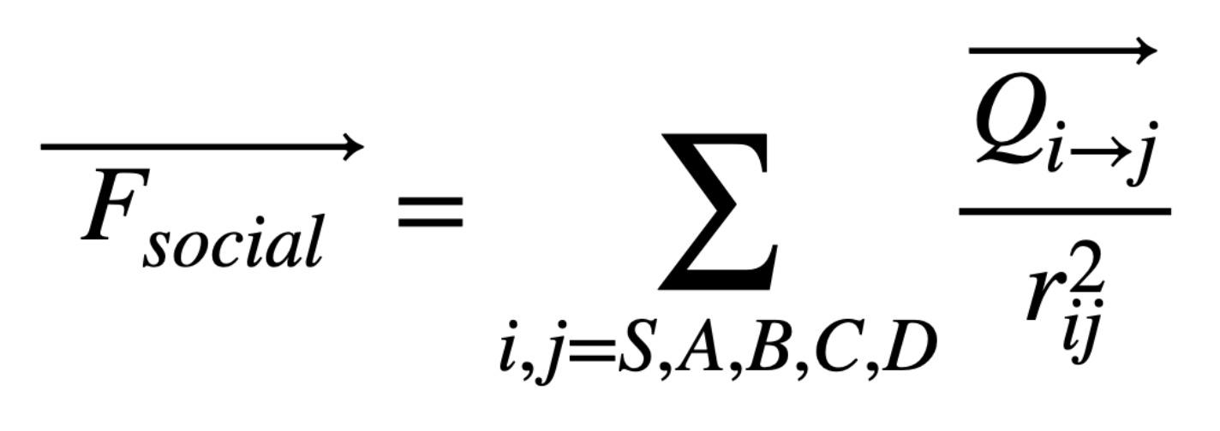
Given the movement force for each agent, we then determined all the agent’s movement together at _{n} to _{n+1} (Fig. 2). F_{social}, which is the sum of movement forces from all other agents on one specific agent, is a vector that indicates the movement direction of the agent in the grid. Note that because the grid is discrete rather than continuous, we applied approximated motion directions such that if a F_{social} unit vector was less than 0.5, the agent does not move. If it was over 0.5, the agent was triggered to move in the resultant direction by one unit in the grid. At times, we observed the phenomena of agents orbiting each other; for example a_{i} and a_{j} orbiting each other, leading to the result of a_{i} and a_{j} holding the same coordinates in the grid on _{n} and _{n+1}. We set flags to interrupt such infinite orbiting when occuring, since this continuous term does not provide further social information in our simulation.

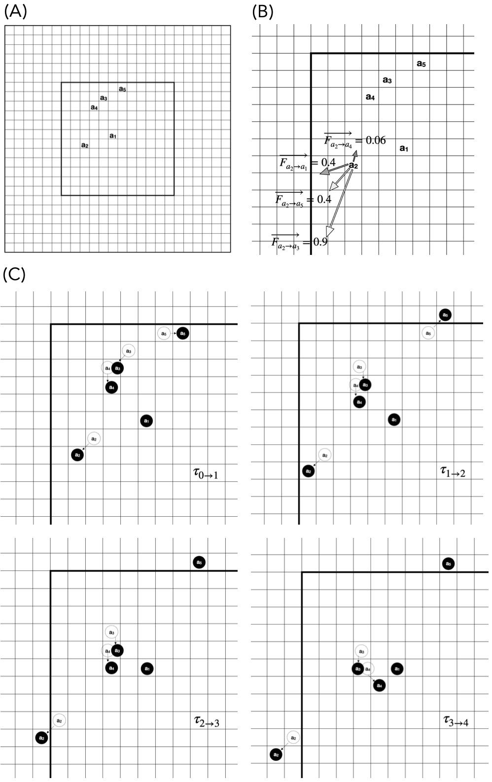
Figure 2 (A) shows one simulation trial as time step ₀ , which represents the initial state of agents. Figure 2 (B) is an example of calculating a₂’s F_{social.} The arrows labeled with different represents the movement forces a₁₋₅ acting on a₂. The arrow’s grey scale represents the social score and has the same scheme as in Figure 1 (B). Due to the sum of F_{social}, a₂ moves both left and down in ₁. In Figure 2 (C) the unfilled circles represent the agents’ places at 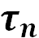, while the black circles represent the agents’ places at 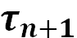. This figure displays how the agents move in the 24*24 grid from 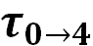.

2.3 Grid collection to simulation data
The simulation data is constructed by agents initial positions and the agents movements in the grid. The initial positions of the agents in each grid were set randomly. With the random starting positions and the rule of movements described above, a set of data was generated based on the social structure between agents.
Each training set of this model was composed of 10,000 different grids as a set of simulation data. Grids were compiled into tensors for model input, with each tensor (10*trajectory) including the final state and the last 10 movements of the grid. If there were less than 10 movements, then the first few steps would be zero padded. In set 1 (social score mean = 0) of the three training sets, 6936 of 10000 tensors were zero padded; in set 2 (social score mean = 16), 9894 of 10000 tensors were zero padded; in set 3 (social score mean = -8), 8747 of 10000 tensors were zero padded.
Each tensor was constructed from 10 trajectories (12*12*31), while the trajectories represented the movements in the grid. The initial position was first recorded in 5 layers, then the movements of the five agents were recorded by up, down, left, right, and goal separately. This results in 5 layers for each agent and a total of 25 layers to record all agents’ movements. An additional layer which is recently all zero padded allows further implementation for adding obstacles into the grid. However, this is not currently of use in this present study.

2.4 ToMNet 2.0 model structure
The ToMNet 2.0 model is trained by batches, based on [16] setting the batch size as 16, 16 sequences of randomized tensors are input jointly to the model. ToMNet 2.0 consists of two separate parts (Fig. 3). The first part is the character network where the input consists of the tensors of simulation data channels (e.g. directional motions of each agent at each time step) mentioned above. The goal of the character network is to learn state representations and capture essential features of the agents’ behavioral states by abstracting information from the trajectory T_{j} that captures the motion of each agent at each time step into character embeddings (e_{char, j}). The abstraction is achieved through a learned neural network function, denoted as f_{char}, which encapsulated operations including a 1-layer 3x3 convolutional network, a 5-layer residual network, average pooling, an LSTM layer, and a fully connected layer. The character embedding was obtained by applying the function f_{char} ← g_{char} that maps input tensors T_{j} to an embedding to the input trajectory tensor T_{j} such that e_{char, j} = f_{char} (T_{j}). This process was repeated for all trajectories, and the character embedding were summed to obtained an aggregated representation ∑^{N}_{j = 1} e_{char, j}. The learning loss function used was the softmax cross entropy and regularization loss such that total loss = cross-entropy loss + ∑regularization loss. Cross-entropy minimizes the discrepancy between predicted class probabilities and the actual labels, enhancing prediction accuracy. Regularization helps maintain model simplicity and prevent overfitting.
The output is the character embedding (e_{char}), which is an abstraction of the information given in the input tensors. The character network first inputs the tensor (10*12*12*31) into a 1-layer 3x3 convnet, expanding the tensor into 10*12*12*32, then passes through a 5-layer resnet with 32 channels, batch normalization and ReLu nonlinearities. The resnet is followed by average pooling and leads dimension reduction into 10*32. The 2-D tensor then passes through LSTM with 1024 channels and a fully connected layer, this returns a linear output that represents the category of all the output possibilities (e_{char}). Note that the channel amount and matrix dimensionality mentioned above those set as 1024 denote the possible sets of results for the grid output.
The other part of the ToMNet 2.0 model is the prediction network. This is a parallel structure to a character network that predicts the result of untrained grids. The goal of the prediction network is to leverage the character embedding and untrained grid (query state q_{k}) to predict subsequent behavior of the agent. The prediction network is represented by the function f_{pred} that maps e_{char} and q_{k} to a probability tensor g_{k}, indicating the prediction output. The prediction is done by estimating the given agent’s policy, denoted as πˆ^{(hat)}(·|q_{k} , e_{char}), representing the predicted policy given the observed state and character embedding. This captures abstracted representation of the environment and underlying social information, returning a policy that is the probability distribution over possible action that the agent might take in the given state. We do not assume the agent’s politics π_{i} is optimized for the respective task. The input of prediction network is e_{char} from character network, and an untrained grid named query state (q_{k}), this grid contains only the initial state but without the moving steps (12*12*31). The e_{char} is spatialized before concatenating with query state (q_{k}), then passed through a 1-layer 3x3 convnet, transferring the tensor into 12*12*32. The tensor is then passed into a 5-layer resnet with 32 channels having the similar setting in character network. Followed by a 3x3 convnet and average pooling layer the dimension is reduced into 32*1, after the fully connected layer and softmax the linear output indicates the prediction of q_{k}, which is labelled as g_{k} in Fig. 3. The output g_{k} after the softmax is a probability tensor with size of 1024*1 indicates the prediction output of the untrained grid.
The ToMNet model employs the Adam optimizer for training, which dynamically adjusts learning rates based on estimates of the gradients' first and second moments. This approach allows for efficient convergence to a local minimum, particularly in scenarios with noisy or sparse gradients. The learning rate is adjustable through a placeholder, enabling dynamic updates during training. According to [19], the model’s training, validation, testing, proportion is 8:1:1, learning rate = 10⁻⁴, and training set = 10⁴.
During training and validation, the model's performance is evaluated using the Top-1 error rate, which measures the frequency at which the model's most confident prediction is incorrect. The primary goal is to minimize this error rate, ensuring the model not only achieves high accuracy on the training data but also generalizes effectively to unseen data. This comprehensive approach, supported by dynamic learning rate adjustments and dropout techniques for regularization, facilitates the model's robust training and effective performance across different datasets.
The model works under the environment of python = 3.6.10 and tensorflow = 1.12.0.
ToMNet2.0 iteratively updates its weights to minimize the above defined loss function. As it learns from the dataset that represents complex agent interactions within the environment, the model’s parameters adjust to better capture the latent, hidden states and dynamics of the agents. The mathematical convergence using the ToMNet2.0 model trajectory settles on a minimum closest to the true hidden state of the environment. It can be understood as the minimized error of predicted behavior of five agents over novel trajectories such that the abstracted character states reflect most closely to latent states. While this may not be the most efficient computational architecture to obtain accurate predictions, it edges closer to a more naturalistic theory of mind.
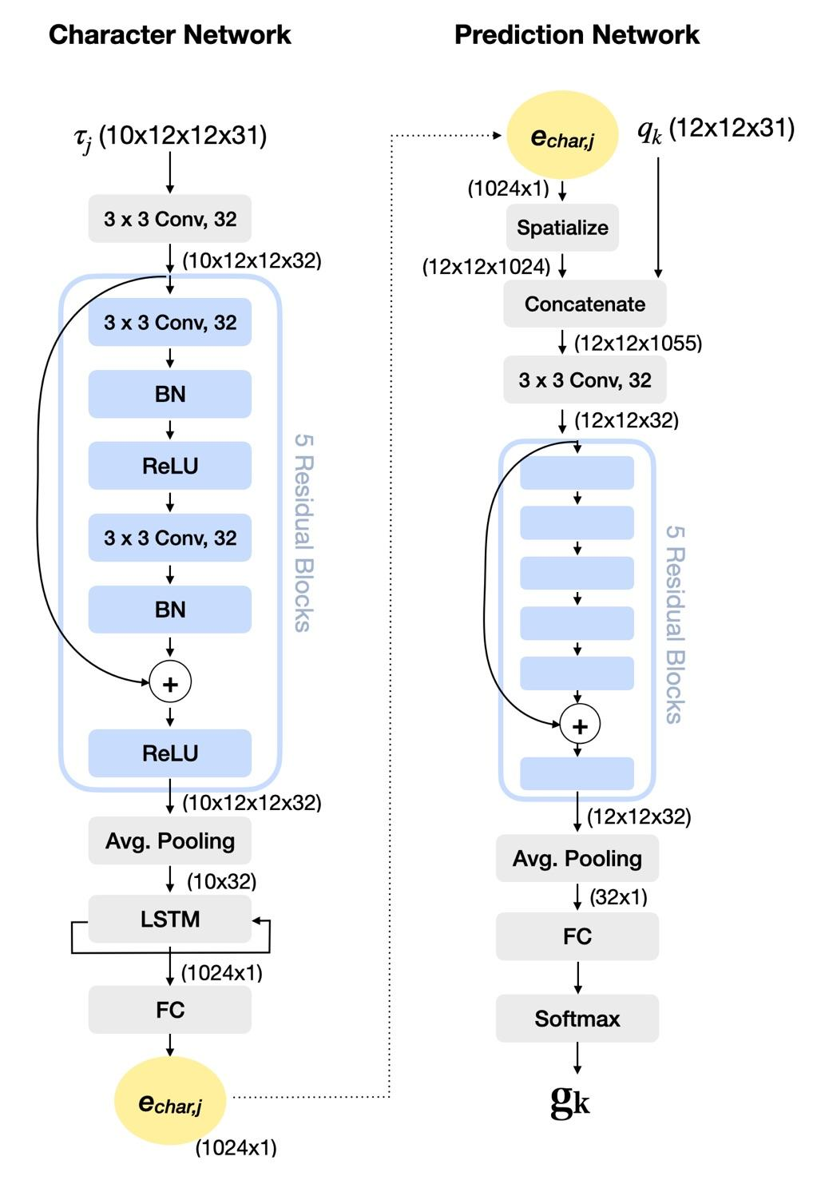
Figure 3. A schematic structure of ToMNet 2.0. The parentheses in the figure indicates the tensor size. Conv: convolutional layer, BN: batch normalization, ReLU: rectified linear unit activation function, Avg. Pooling: average pooling layer, LSTM: long short-term memory layer, FC: fully connected layer, 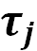 : input trajectory, e_{char,j:} character embedding, q_{k}: query state, g_{k}: prediction result.
3. Experimental Results

3.1 Evaluating ToMNet 2.0 performance
The performance of ToMNet 2.0 is evaluated by two different aspects, one examines the model performance by learning curve, the other focus on the prediction result of untrained 1000 grids to evaluate ToMNet 2.0’s performance. Evaluating the model’s performance by the learning curve is a common measure in machine learning and will be further elaborated in section B.
Evaluating ToMNet 2.0’s achievement on learning hidden social network structure, we extracted various testing results of ToMNet 2.0 after training in predicting the outcomes of 1000 untrained grids. Considering that grid world simulations essentially index the spatial relation information between the five agents (a_{i}), we measured the model’s learning performances by recording the ‘contact or not’ instances. Such instances were noted down as 1 when the specific two agents settled clustered (in adjacent coordinate locations), while a recording of 0 was logged when the final settling locations for two agents were not adjacent, e.g., a₁ and a₄ settled with contact = 1 in Fig. 4A. With this setting, each grid could be transformed into a 0 or 1 10 binary digit table contains 10 integers (Fig. 4B & C). We also apply this 10 binary digit table format to the ground truth, for further comparison between ToMNet 2.0’s prediction. Here the ground truth stands for obtained by implementing letting the grid world movement force algorithm play out based on the same start locations of the 1000 untrained grids.
The format of a 10 digit table representing each grid terminal state is then applied to various different evaluations. We first summed all 1000 untrained trial ToMNet 2.0 outputs of 10 binary digits table into a single 10 integer vector counting table as our testing results, by summing up the 1000 grid’s prediction result, we get to evaluate the trends of agents adjacent frequency rather than only comparing individual grid prediction with ground truth result. The ground truth grids results are also summed up and the comparison results are further discussed in section B. The 10 integer vector counting table is then applied to measure the RMSE between prediction and ground truth which is further discussed in section C.
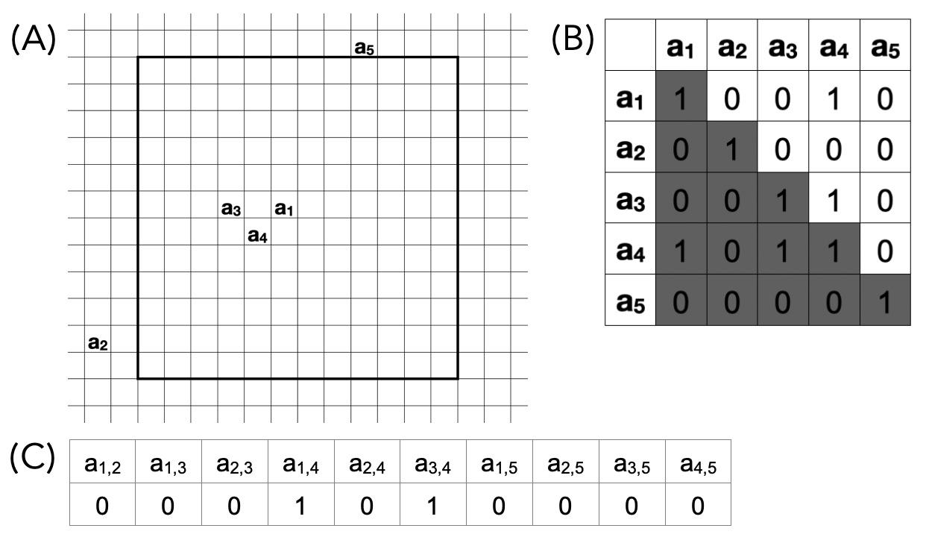
We also calculated the accuracy by matching the 10 digit table of prediction with the ground truth. If the 10 digit table of each single prediction matches the ground truth the correctness = 1. Summing up the correctness of all 1000 grids and dividing into 1000 equals the accuracy of the prediction set.

Figure 4. In (A) shows the final state of this grid. (B) The values of the table expresses the convergence of agents, 1 stands for settle with clustered, 0 on the contrary. Both a₁ and a₃ neighboring a₄, and are marked 1 in the table. (C) Then the 10 values are transformed into a 0 or 1 10 binary digit table.

3.2 ToMNet 2.0 outputs and results on training data
In this study, we trained ToMNet 2.0 separately with three different social preferences set as mentioned in the methodology section (Fig. 5). Following the evaluation format mentioned in section A, table 1 shows the resulting 10 integer vectors obtained from ToMNet 2.0’s predictions for the start locations of the 1000 untrained test instances for the three different data set types, comparing with ground truth. Overall, the trends suggests that ToMNet 2.0 did approach having an internal belief of the complex social structures governing the five agents’ movements in grid world. To formally assess this, we used Spearman rank order correlations, which is suitable for comparing ToMNet 2.0’s testing results against the ground truth. A Spearman rank order correlation is performed to test the monotonic similarity of two variables.
The results of training set 1 is stated in Table 1A, this set of simulations has the mean social score 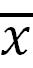 = 0 with SD = 9, min = -16 and Max = 18. The social preferences were learned by ToMNet 2.0, which reflects the models ability to decode the embedded social preference in such distribution. A Spearman rank order correlation was further performed according to the results of Table 1A, and revealed a significant correlation with ground truth, the results were 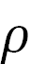 = 0.87, p = 0.001.
In sets 2 & 3 it separately informs two different extreme conditions. For set 2, the agent’s social score mean  = 16 with the SD = 12, min = 0 and Max = 34, in the grid simulation this leads to agents high frequency settling in contact, while in real life projects a group of people without negative social preferences and who all are attracted to each other. A Spearman rank order correlation was further performed according to the results of Table 1B, which shows significant correlation with ground truth, the results were  = 0.75, p = 0.011.
For set 3, the agent’s social score mean 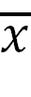 = -8 with the SD = 10, min = -25 and Max = 5, this reflects a situation where agents rarely contact in this set of simulation, in real life indicates a group of people who rarely interact. A Spearman rank order correlation was further performed according to the results of Table 1C, and shows significant correlation with ground truth, the results were  = 0.9, p = 0.0004.
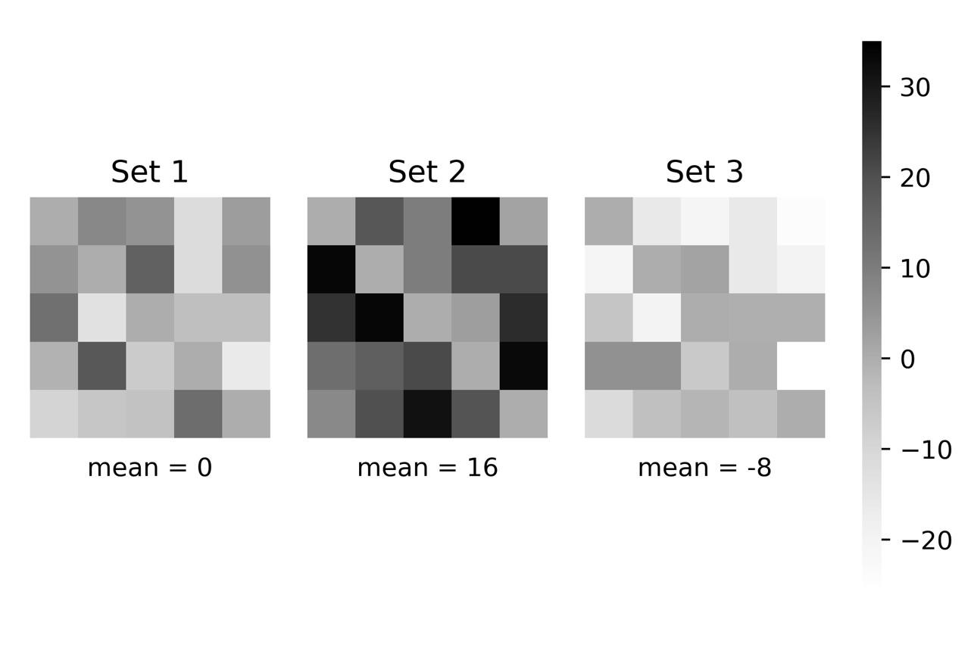
Figure 5. The social preference heat map of the three training sets.

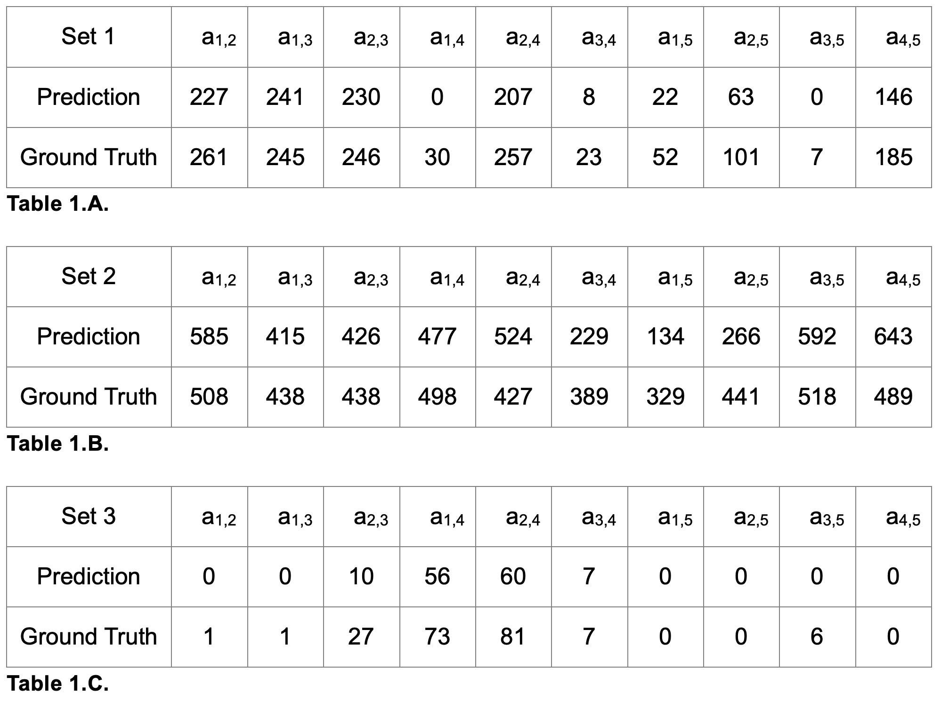
Table 1. The summary of three sets of testing on ToMNet 2.0.

Next, in order to evaluate the model’s performance, we graphed the learning curve of each set of training (Fig. 6). The learning curve is plot by training error and validation error over training steps. In our model we apply the top 1 error rule to calculate training and validation error, which is the percentage of time that the classifier did not give the correct class the highest score. In Fig. 6A & C the model is regarded as a good fit training with some noise, however in Fig. 6B the error rate remains steadily at a high level, the possible reason here may relate to how the model evaluates the error. The accuracy is calculated by the prediction of the final states of the grid world, this indicates that the correctness is only counted while ToMNet 2.0 predicts the exact correct outcome of each grid world simulation. However, there are limitations in this current model to pick up such dynamic but precise information during current simulations, meanwhile, similar performance might occur in real life social interaction, since in an attractive interacting scene, humans may not have sufficient variation to distinguish other’s social preferences.

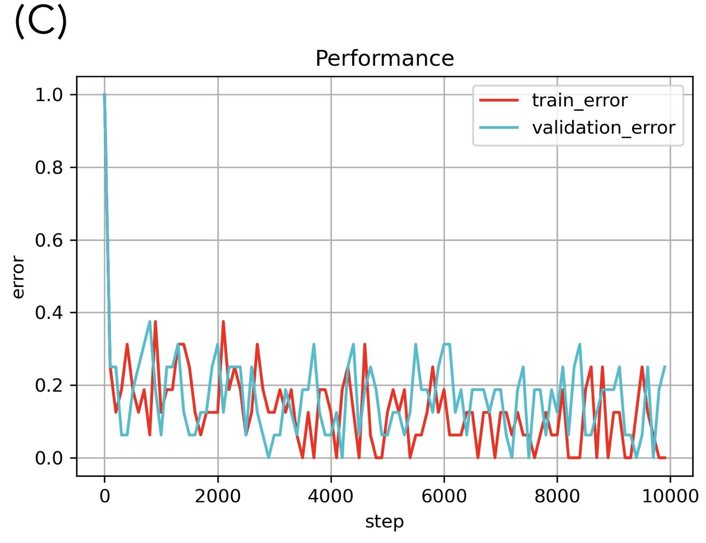
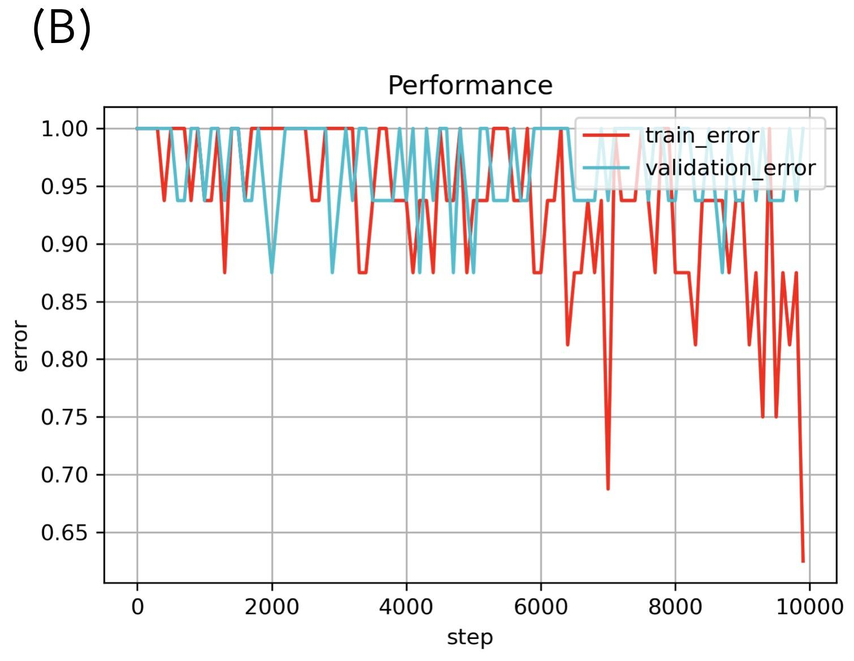
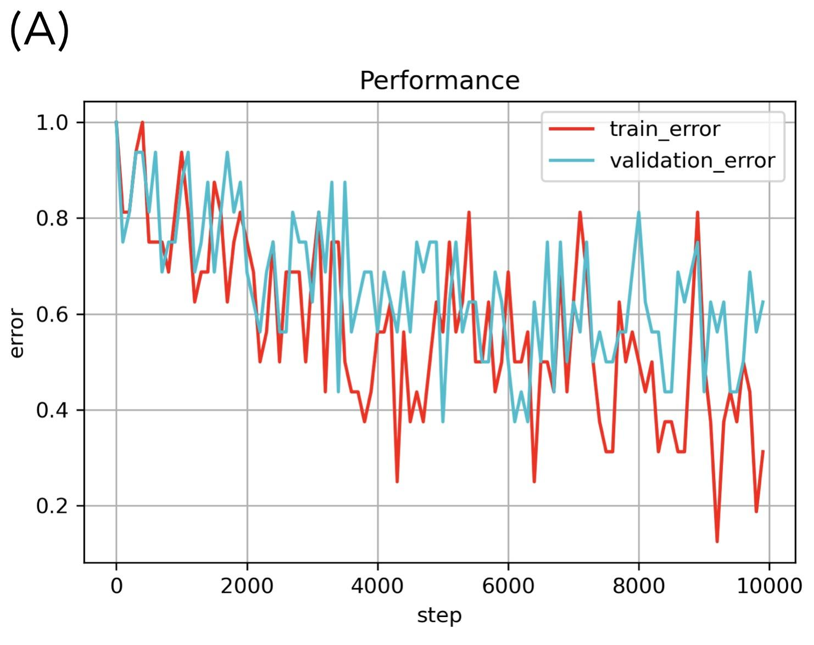
Figure 6. The training performance evaluated by learning curve.
Fig. 6 (A) presents a properly trained model with an acceptable error and without over/under training. Fig. 6 (B) states such social structures may need an increment of model complexity. Fig. 6 (C) reveals the information embedded may be too simple this leads to early settlement but without overfitting.

3.3 Random rate comparison
To further evaluate the model performance, we tested the three sets of trained model with other sets of grids, in which social scores were permuted (i.e., the social preferences had similar ranges but the specific associations were not the same as the one which the model was trained for). We performed the direct 10 integer vector counting, the RMSE against ground truth, and the accuracy as our measurement, details are stated in section A.
In Fig. 7A & C the performances were well distinguished for the trained social structures and indicated ToMNet 2.0 learned the information embedded in the training sets. In Fig. 7B the analysis states that ToMNet 2.0 still gain partial information and forms a similar but imperfect embedded preference through training.
The analysis of RMSE is aimed to measure the difference between ground truth, prediction, and permuted sets. The pattern plotted in Fig. 7 indicates that RMSE may not be a very precise evaluation whether ToMNet 2.0 is well trained, since all three sets seems to hold similar patterns at Fig. 7. However note the value of RMSE at set 2 is significantly grater than the other two sets, which is a sign of the imperfect uptake of preference information.
The analysis of accuracy is a relatively rigorous evaluation of ToMNet 2.0’s performance, since accuracy is calculated by evaluating the testing of each individual grid world movement trial. Thus, we should be aware of this demand in evaluating the accuracy of this model when decoding Fig. 7. Critically, note that ToMNet 2.0 is expected to learn the social network structure rather than the precise ground truth of each grid. In conclusion, only focusing on the poor accuracy in Fig. 7 may lead to disregarding the partial information ToMNet 2.0 gained throughout the training process. Rather, we suggest that when evaluating ToMNet 2.0, the summed 10 integer counting vector should also be referred to instead.
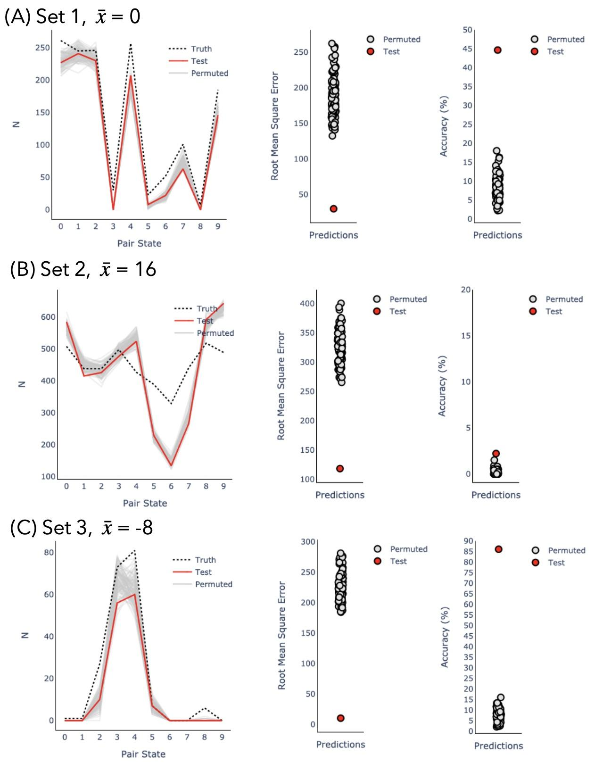
Figure 7. Trained model testing with random social setting grids.
In Fig. (7), the red dot represents a trained ToMNet 2.0’s prediction of the testing data with the same social setting. Other grey dots are the trained ToMNet 2.0’s prediction of the randomly generated social settings. RMSE is calculated by the sum of all 1000 grids prediction results, while accuracy is calculated by judging the correctness of all 1000 grids.

4. Discussion

4.1 Implications
ToMNet2.0 builds off of ToMNet+ and is similarly designed to infer goal-directed behavior from a single shot of trajectories using trainable parameters residing within the character network and prediction network components of the model. The main extension is the five way dynamic bidirectional relationship between agents. Our findings highlight the potential of machine applications that infer implicit human preferences from third observation. We demonstrate that an artificial neural network with ToMNet2.0 based architecture can accurately model real hidden social networks reflected in complex, bidirectional relationships. This is distinct from previous studies because of its use of hidden associative structures in addition to abstracted preferences from simulated agents. According to the results, these findings suggest that the designed structure of ToMNet 2.0 learns from the social preference based training set and has the ability to decode implicit social preferences. This achievement remains absent in the previous mentioned models. While this result indicates that ToMNet 2.0 has the ability to learn information embedded in a dynamic social interaction, to become an indispensable implementation in socially assistive machines simulation in a more realistic format should further be tested. Since ToMNet 2.0 is able to tell the embedded five-bodied social preference, it becomes the first step to optimize social robots applied in multi-users scenarios. With some adjustments on the model design to reduce the required amount of training materials or broaden the acceptance of input formats may benefit the field of socially assistive robots more widely.
In the results where agents are attracted to each other (set 2), seemingly the model was underfitted, even though the summed up of prediction results correlates with the ground truth. Thus, ToMNet 2.0 still gained some information about agent’s social structure despite limited variance in agent outcomes. In human social interaction, people may not be as precise as required in our modeling. In other words, if the aim is to develop models like ToMNet 2.0 that operate without numerous training data or even with a more abstract model setting, the application of this approach should be quite broad.
The ToMNet model was proven to pass Sally Anne test in previous studies, furthermore in this research, ToMNet 2.0 has the ability to form perceptions of abstract concepts such as multi-agent social networks. By contrast, ChatGPT as a Large Language Model (LLM) which was also reported to pass some levels of theory of mind (ToM) tests still had limitations in achieving theory of mind. Recent research successfully detects ToM on GPT-4 reports the accuracy raises due to producing longer-form answers. However, the author mentioned further testing on distinguishing inferential reasoning and GPT-4’s ToM should be performed [22]. According to the ToM ability tests performed on GPT-4, LLM’s requires script inputs, while social interaction contains not only verbal input but also lots of non-verbal stimuli. When implementing such stimulus, ToMNet 2.0 simply requires stimuli transformation into social scores, while LLM would request for a script describing the non-verbal stimuli. Indeed, there were some similar achievements for both ToMNet 2.0 and GPT-4 when testing the machine's theory of mind, nonetheless to approach the abstract conceptualization of human social network, ToMNet 2.0 seems a slightly better option than GPT-4.

4.12 Application on human social interaction data
Our intention in the near future is to apply ToMNet 2.0 on human social interaction data. In the social interaction game five participants are recruited, they are required to play a board game named Avalon where each participant plays a specific character. The character participants role playing forms loyalties and adversaries between each other whilst the game quest flows. Meanwhile we record participants' head orientation, face emotion expressions, eye gaze and speech to reflect the dynamic social preference during the game. The collected data is preprocessed and prepared for training and testing on ToMNet 2.0, such dynamic human social interaction data application stands for a precious attempt on evaluating a model's ability to process human social networks.

4.2 Towards Human Theory of Mind
ToMNet 2.0 models Theory of Mind with respect to the neurobiological ToM network. A purely machine-centered artificial neural network focused on cognitive function rather may not consider the energy and biological constraints that are reflected in the ToM system. For example, using large quantities of data to learn is unrealistic to what is needed for human ToM. Neuroscience research has illuminated the key brain regions and networks associated in core ToM processes, including the medial prefrontal cortex (MPFC), precuneus (PC), and bilateral temporoparietal junction (RTPJ/LTPJ) [21]. This biological network is uniquely activated by domains of social information. Such biologically based findings underscore that the biological development of ToM is a complex, gradual process that involves multiple brain regions and their interactions. This robust structure contributes to the stability of ToM functionality across novel social situations and incomplete information. Similarly, ToMNet 2.0’s unique architecture ensures ToM processes by its consistent representation of hidden states, arguably a more fundamental assessment of ToM rather than psychological tasks. Critically, this internal model of another agent’s beliefs, intentions, and social preferences does not require large amounts of data because it is distinctly not pattern recognition or emotion-action mapping. Furthermore, just like the human brain, ToMNet 2.0 integrates spatial and temporal representations into a context specific policy that is carried out in novel social environments.

4.2 Limitations
ToMNet 2.0 has several limitations. First, the input format is limited to grid format, which restricts the application to a more realistic social stimulus. Second, the social structure is fixed as constants, however in reality human social preference changes by time. Third, the output matrix limits the information of social networks. Social interactions are bidirectional in the initial social network settings (P_{i,j}^{efferent} and P_{i,j}^{afferent}). However, the output matrix can only provide a sum up result of the social interaction. Since the model will always take on the perspective of an observer, the asymmetrical social preferences are not accessible to the model learning process as only the totality of the movement is being observed. For the purpose of modeling human theory of mind, the partial observability is intentional, as we hope the model can learn from limited environmental and behavioral information. However, oftentimes humans take on the perspective of individual agents and theorize about X_{i,j}^{efferent} and X_{i,j}^{afferent} social preferences, allowing for richer social network modeling. Lastly, in the case when social score  > 0, the performance seems not as accurate as other cases, which may be reasonable both in stimulation and realistic. When discuss about simulation in the case of  > 0, the agents converge due to the F_{social} setting. While in realistic social scenario, a group of friends interacting may be the example of  > 0, an observer may not be able to tell the individual's degree of favor between the group.
Future iterations of ToMNet might seek to incorporate simulated predictions of social X_{i,j}^{efferent} and X_{i,j}^{afferet} instead of using an average social score from observation. As the model learns from social network interactions, it would leverage priors and character net embeddings to model the nuanced bidirectional relationships. This approach would imbue the model with a capacity to infer more complex intergroup dynamics. Subsequent analysis could further test the robustness of the model, by validating ToMNet against human performance when shown the same social network interactions. Taken together, these advancements could significantly enhance the accuracy and applicability of ToMNet in real-work social machine interactions.

4.3 Conclusion
ToMNet 2.0 is proven to comprehend a more complex social network, however this is restricted in the present settings of this model, there are lots of further attempts worth applying on such models to aid machines understand social scenarios more efficiently.
References
1. Feil-Seifer, D. and M.J. Mataric, Human RobotInteraction.
2. Duffy, B.R., Anthropomorphism and the social robot. Robotics and Autonomous Systems, 2003. 42(3-4): p. 177-190.
3. Henschel, A., G. Laban, and E.S. Cross, What Makes a Robot Social? A Review of Social Robots from Science Fiction to a Home or Hospital Near You. Curr Robot Rep, 2021. 2(1): p. 9-19.
4. Whelan, S., et al., Factors Affecting the Acceptability of Social Robots by Older Adults Including People with Dementia or Cognitive Impairment: A Literature Review. International Journal of Social Robotics, 2018. 10(5): p. 643-668.
5. Matarić, M.J., Scassellati, B., Socially Assistive Robotics. In: Siciliano, B., Khatib, O. Springer Handbook of Robotics., 2016.
6. Stock-Homburg, R., Survey of Emotions in Human–Robot Interactions: Perspectives from Robotic Psychology on 20 Years of Research. International Journal of Social Robotics, 2021. 14(2): p. 389-411.
7. Johanson, D.L., H.S. Ahn, and E. Broadbent, Improving Interactions with Healthcare Robots: A Review of Communication Behaviours in Social and Healthcare Contexts. International Journal of Social Robotics, 2020. 13(8): p. 1835-1850.
8. Papadopoulos, C., et al., The CARESSES Randomised Controlled Trial: Exploring the Health-Related Impact of Culturally Competent Artificial Intelligence Embedded Into Socially Assistive Robots and Tested in Older Adult Care Homes. Int J Soc Robot, 2022. 14(1): p. 245-256.
9. Pu, L., et al., The Effectiveness of Social Robots for Older Adults: A Systematic Review and Meta-Analysis of Randomized Controlled Studies. Gerontologist, 2019. 59(1): p. e37-e51.
10. Koh, W.Q., et al., Barriers and facilitators to the implementation of social robots for older adults and people with dementia: a scoping review. BMC Geriatr, 2021. 21(1): p. 351.
11. Langley, C., et al., Theory of Mind and Preference Learning at the Interface of Cognitive Science, Neuroscience, and AI: A Review. Front Artif Intell, 2022. 5: p. 778852.
12. Astington, J.W. and J.M. Jenkins, Theory of mind development and social understanding. Cognition & Emotion, 1995. 9(2-3): p. 151-165.
13. Premack, D. and G. Woodruff, Does the chimpanzee have a theory of mind? Behavioral and Brain Sciences, 2010. 1(4): p. 515-526.
14. Williams, J., S.M. Fiore, and F. Jentsch, Supporting Artificial Social Intelligence With Theory of Mind. Front Artif Intell, 2022. 5: p. 750763.
15. Hernandez-Leal, P., B. Kartal, and M.E. Taylor, A survey and critique of multiagent deep reinforcement learning. Autonomous Agents and Multi-Agent Systems, 2019. 33(6): p. 750-797.
16. Neil C. Rabinowitz, et al., Machine Theory of Mind. ArXiv Prepr., 2018. arXiv:1802.07740.
17. Hao Zhu, G.N., Yonatan Bisk, Few-shot Language Coordination by Modeling Theory of Mind. 2021. arXiv:2107.05697.
18. Stojnic, G., et al., Commonsense psychology in human infants and machines. Cognition, 2023. 235: p. 105406.
19. Yun-Shiuan Chuang, et al., Using Machine Theory of Mind to Learn Agent Social Network Structures from Observed Interactive Behaviors with Targets. 2020 29th IEEE International Conference on Robot and Human Interactive Communication (RO-MAN), 2020.
20. Goh, J.O.S., H.-Y. Hung, and Y.-S. Su, Chapter Seven - A conceptual consideration of the free energy principle in cognitive maps: How cognitive maps help reduce surprise, in Psychology of Learning and Motivation, K.D. Federmeier, Editor. 2018, Academic Press. p. 205-240.
21. Schurz, M., Radua, J., Aichhorn, M., Richlan, F., & Perner, J. (2014). Fractionating theory of mind: A meta-analysis of functional brain imaging studies. Neuroscience & Biobehavioral Reviews, 42, 9-34. https://doi.org/10.1016/j.neubiorev.2014.01.009

22. Shima Rahimi Moghaddam, C.J.H., Boosting Theory-of-Mind Performance in Large Language Models via Prompting. 2023. arXiv:2304.11490

24. Theriault, J. E., Waytz, A., Heiphetz, L., & Young, L. L. (2017). Examining overlap in behavioral and neural representations of morals, facts, and preferences. Journal of Experimental Psychology: General, 146(11), 1586–1605.
https://doi.org/10.1037/xge0000350

